

**Tribhuvan University**

**Faculty of Humanities and Social Sciences**

**A PROJECT REPORT**

**ON  
Dosedash** “E-commerce Site”

**Submitted to:**

**Department of Information Technology**

**Kathford International College of Engineering & Management**

***In partial fulfillment of the requirement for the Bachelors in Computer Application***

Submitted by:

**Aayush Timalsina (6-2-456-03-2020)**

March 2024

Under the supervision of

**Ishwar Dhungana**

# **Abstract**

**DoseDash** is an e-commerce service which provides a platform where people can buy for pharmacy supplies cater to patients with **chronic** conditions who require regular medication refills. Offer delivery and reminder of **medications** based on doctor's prescriptions and patient needs. It focuses on patients with chronic conditions requiring consistent medication, like diabetes, high blood pressure, asthma, or thyroid issues. This system will be using agile methodology. The website is built using HTML, CSS,Bootstrap, and JavaScript as front-end tools, Python and Django framework as back-end tools, and SQLLite server for database development.

**Keywords: DoseDash, medications, chronic**

# **Acknowledgement**

We would like to express our heartfelt gratitude to everyone who has contributed to the successful completion of this project. We extend our sincerest thanks to our project supervisor, **Mr. Ishwar Dhungana**, for his invaluable support, guidance, and insightful suggestions throughout the project. His constant supervision and coordination have been instrumental in our achievements.

We are immensely appreciative of all the individuals who have been involved in this project. Their inspiration, encouragement, and constructive feedback have played a significant role in shaping and refining our work. Without their contributions, it would have been impossible to develop the project within the given time frame.

Lastly, we would like to express our thanks to all the members of the **Department of Information Technology** and the entire team at "**Kathford International College of Engineering & Management**" for providing us with a conducive environment to carry out this project. Their continuous support and resources have been indispensable in our journey.

We are deeply grateful to everyone involved and look forward to utilizing the knowledge and experience gained from this project in our future endeavors.

**Table of Contents**

**Abstract** i

**Acknowledgement** ii

**List of Figures** v

**List of Tables** vi

**List of Abbreviations** vii

**CHAPTER 1: INTRODUCTION** 1

**1.1** **Introduction** 1

**1.2** **Problem Statement** 1

**1.3 Objectives** 1

**1.4 Scope and Limitation** 2

**1.5 Report Organization** 2

**CHAPTER 2: BACKGROUND STUDY AND LITERATURE REVIEW** 4

**2.1 Background Study** 4

**2.2 Literature Review** 5

**CHAPTER 3: SYSTEM ANALYSIS AND DESIGN** 6

**3.1 System Analysis** 6

**3.1.1 Requirement Analysis** 7

**i. Functional Requirements** 7

**ii. Non-Functional Requirements** 8

**3.1.2 Feasibility Analysis** 9

**i. Technical Feasibility** 9

**ii. Operational Feasibility** 10

**iii. Economic Feasibility** 10

**iv. Schedule Feasibility** 10

**3.1.3 Data Modeling (ER Diagram)** 10

**3.1.4 Process Modeling (DFD)** 11

**3.2 System Design** 13

**3.2.1 Architectural Design** 14

**3.2.2 Database Schema Design** 14

**3.2.3 Interface Design** 14

**CHAPTER 4: IMPLEMENTATION AND TESTING** 16

**4.1 Implementation** 16

**4.1.1 Tools Used** 16

**4.1.2 Implementation Details of Modules** 16

**4.2 Testing** 18

**4.2.1 Test Cases for Unit Testing** 18

**4.2.2 Test Cases for System Testing** 20

**CHAPTER 5: CONCLUSION AND FUTURE RECOMMENDATIONS** 21

**5.1 Lesson Learnt/Outcome** 21

**5.2 Conclusion** 21

**5.3 Future Recommendations** 21

**REFERENCES** 22

**APPENDICES** 23

# **List of Figures**

**Figure 1: Agile Methodology** 6

**Figure 2: Use Case Diagram of Gym Management System** 8

**Figure 3: Gantt's Chart of Gym Management System**  10

**Figure 4: ER Diagram of Gym Management System** 11

**Figure 5: Context Diagram of Gym Management System** 12

**Figure 6: DFD of Gym Management System** 13

**Figure 7: Database Schema Design of Gym Management System** 14

**Figure 8: Homepage of Gym Booker** 15

**Figure 9: SFD of Gym Management System** 17

**Figure 10: Simply Book Landing Page** 22

**Figure 11: ClassFit Landing Page** 22

**Figure 12: GymDesk Landing page** 23

**Figure 13: GymBooker Landing Page** 23

**Figure 14: Sign in Page** 24

**Figure 15: Dashboard of GymBooker** 24

# **List of Tables**

**Table 1: Unit Test Case - 1 (Login)**

**Table 2: Unit Test Case - 2 (Feedback)**

**Table 3: Unit Test Case - 3(Change Password)**

**Table 4: System Test Case - 4 (Customer Query)**

# **List of Abbreviations**

**BCA:** Bachelor in Computer Application

**CSS:** Cascading Style Sheet

**DJANGO:** Framework of Python for Web Development

**ER Diagram:** Entity Relationship Diagram

**HTML:** Hypertext Markup Language

**JS:** JavaScript

**MS Office:** Microsoft Office

**SQL Lite:** Structured Query Language Lite

**PK:** Primary Key

**PYTHON:** Backend Programming Language

**VS Code:** Visual Studio Code

# **CHAPTER 1****: INTRODUCTION**

## **Introduction**

DoseDash is an E-commerce website where people can select and buy desired product anytime. This website is based on online payment method. The website comes with an admin panel and user interface. This website is made with a scripting language like JavaScript, standard markup language like HTML which is assisted by CSS and Python,Django(Framework) at the backend.

DoseDash has a user panel and admin panel. The user panel, where customers can register/login into the website,The buyer can have users add their selected products to cart, view the products, and order the products they have added to cart. In the admin panel, the admin can monitor the user panel as a whole; meaning that the admin can delete any account of the user and Admin can add/remove product. All user data will be stored in the database.

## **Problem Statement**

The problem is that there is still not a reliable application which can manage all the processes related to the pharmacy and sending reminder to end user. This leads to considerable decreases in efficiency, delays, waste in material handling, and financial losses.

Overall, an efficient and user-friendly e-commerce site can benefit users by improving operational efficiency, and creating a more engaging and personalized experience.

## **1.3 Objectives**

The objective of this project is:

* To develop the system for online pharmacy store.

## **1.4 Scope and Limitation**

The notably expected scope of this system are mainly member registration and management, class scheduling and management, and maintenance.

As the project is quite limited in time and in expected scope, there are several limitations. The most notable of those limitations are listed below:

* **Platform Development**: The primary scope of the project includes the development of an e-commerce platform, DoseDash, designed specifically for the purchase of pharmacy supplies. This platform will cater to patients with chronic conditions who require regular medication refills.
* **Delivery and Reminder Services**: The platform will offer delivery services for medications and reminders based on patient needs. This feature aims to ensure that patients receive their medications on time and are reminded of their medication schedules.
* **Target Audience**: The platform is specifically tailored for patients with chronic conditions that necessitate consistent medication, such as diabetes, high blood pressure, asthma, or thyroid issues. This focus ensures that the platform meets the specific needs of these patients.

**Limitation:**

* **Geographical Limitations**: The initial launch of DoseDash may be limited to a specific geographical area, which could restrict its reach to patients outside this area.
* **Regulatory Compliance**: Ensuring compliance with healthcare regulations and privacy laws,could pose challenges in the development and operation of the platform.

## **1.5 Report Organization**

The documentation is divided into five chapters under major headings explaining about gym management system.

**Chapter 1: Introduction**

In this section, we discuss the project overview, problem statement, objective and the scope and limitation of DoseDash.

**Chapter 2: Literature Review**

Describes the “background study” of the website we developed. It also described the “literature review” done before the development of the system.

**Chapter 3: System Analysis and Design**

In this section, we discuss the system requirements which include data modeling and process modeling diagrams i.e., ER Diagram, Context Diagram and Data Flow Diagram. The System Analysis and Design chapter is focused on the process and the data modeling of the system.

**Chapter 4: Implementation and Testing**

Provides an account of the tools used for the development of the system. This also explains the different types of testing carried out during and after the development of the website.

**Chapter 5: Conclusion and Future Recommendations**

In this section, the project is concluded with the result of the proposed method that has been analyzed and recommendations are made according to the result obtained from the analysis.

Finally, Appendices and Bibliography/References compiles the preview of systems GUI and various source codes that were used during the development of the project.

# **CHAPTER 2****: BACKGROUND STUDY AND LITERATURE REVIEW**

## **2.1 Background Study**

In the current era, the trend of online shopping has seen a substantial surge throughout the year, significantly impacting the business landscape. This shift in shopping habits not only provides consumers with a vast array of products but also opens up a plethora of business opportunities and a vast market. Social media has evolved beyond being a platform for self-expression on the internet; it has become a venue for selling products to consumers, transforming into an online marketplace. Due to its numerous benefits, more individuals now favor online shopping over traditional retail methods. Online shopping offers easy access to information, a wide range of choices, competitive prices, and personalized service. The healthcare sector, particularly the pharmacy industry, is another crucial background theory. The need for patients with chronic conditions to have access to regular medication refills is a significant issue. The "DoseDash" project addresses this by providing a platform for the purchase of pharmacy supplies, focusing on the needs of patients with chronic conditions like diabetes, high blood pressure, asthma, and thyroid issues.

## **2.2 Literature Review**

The healthcare industry, particularly in the realm of pharmacy and medication management, has seen considerable transformations in recent times, with a notable rise in individuals opting for regular medication refills and staying informed about their health. A significant challenge faced by patients with chronic conditions is efficiently managing their medication needs and ensuring a seamless experience. Online pharmacy management services, It have emerged as a popular solution to address this challenge.

Following are some of the existing pharmacy which provides the relevant system/services for the users:

* PharmEasy is a consumer healthcare “super app” that provides consumers with on-demand, home delivered access to a wide range of prescription, OTC pharmaceutical, other consumer healthcare products, comprehensive diagnostic test services, and teleconsultations thereby serving their healthcare needs [1].
* Netmeds is one of India’s most trusted pharmacies, dispensing quality medicines at reasonable prices to over 9 million happy customer PAN India.At netmeds, we help you look after your own health effortlessly as well as take care of loved ones wherever they may reside in India. You can buy and send medicines from any corner of the country [2].
* Tata 1mg provides you with medical information which is curated, written and verified by experts, accurate and trustworthy. Our experts create high-quality content about medicines, diseases, lab investigations, Over-The-Counter (OTC) health products, Ayurvedic herbs/ingredients, and alternative remedies.[3].

# **CHAPTER 3****: SYSTEM ANALYSIS AND DESIGN**

## **3.1 System Analysis**

System analysis is performed before deciding the working module of this system. It helps to collect and interpret the facts, identify the problems and decomposition of a system into its components. It was performed to ensure that all the system components work efficiently to accomplish the project.

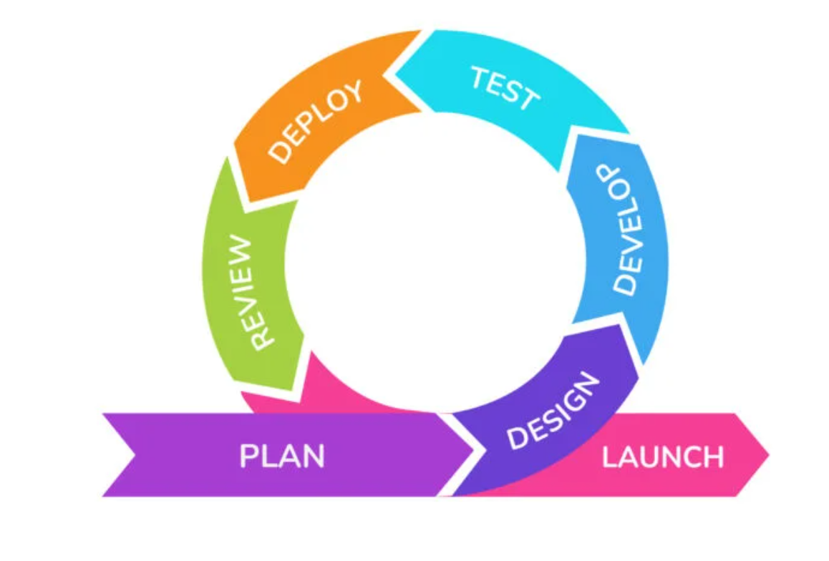

**Figure 1: Agile Methodology [4]**

For the development of this system, the Agile Methodology was used. The Agile methodology is a way to manage a project by breaking it up into several phases. It involves constant collaboration with stakeholders and continuous improvement at every stage[5]. During the development process, the tasks were divided into small time frames to deliver specific features for a release. The main reason for choosing Agile methodology was because it encourages flexible responses to change. The methodology allowed this project to adapt the changing requirements throughout the development process.

### **3.1.1 Requirement Analysis**

Requirement analysis is the initial task to be performed while developing the system.

### **i. Functional Requirements**

Functional requirements for a system describe system behavior and focus on the needs of the users to accomplish their tasks.

* When the user selects ‘shop,’ it must be able to look at the display item.
* When the user selects ‘login’ or ‘sign up,’ it must be able to display the login/signup form.

The system has a user and admin for interaction with the system. The user and admin login with their credentials and are directed to their panel. As shown in the figure below, users and admin have their interaction features with the system. As for the user, he/she can login, view products give feedback, and logout. Whereas the admin can log in as similar to the user. In addition, an admin can manage the users and add/remove products, view reminder, transaction to the system, and later log out from the system.

1. **Register/Login and Logout**: This feature is used by all actors in the system to register/login themselves providing their name, phone number, email, username, and password.
2. **View shop**: User can view shop .
3. **Provide Feedback**: User can provide feedback related to the system.
4. **Manage Account**: User can manage their account details.
5. **Manage user/admin**: System admin can manage the user/admins count in the system.
6. **Manage Product**: Admin can login to system and manage the product, reminder.

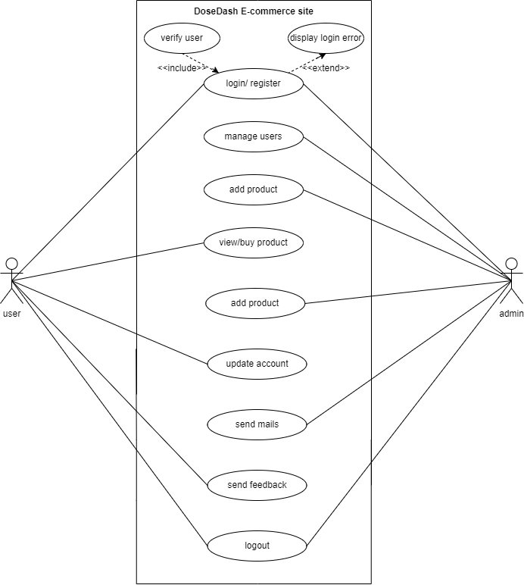

**Figure 2: Use Case Diagram of DoseDash**

### **ii. Non-Functional Requirements**

Non-functional requirements are an important aspect of designing an e-commerce portal. These requirements describe how the website should perform and operate, beyond its basic functionality. Here are of the non-functional requirements that should be considered when designing an e-commerce portal:

1. **Usability**: This system is user-friendly, with simplicity in navigation and easy-to-understand features. Users are able to easily search for classes.
2. **Performance**: This system is fast with minimal lag time between pages and actions.
3. **Security**: User and admin are able to login into the system using their personal credentials. Those credentials are secured by the system.
4. **System requirements:**

The system requirements of the system are mentioned below:

**Software specifications**

Computer software specifications that have been used for development:

* Operating System: Ubuntu LTS 22
* IDE: Visual Studio Code
* Programming Language: HTML, CSS, JS, Python (Django)
* Back End Database: SQLLite

**Hardware Specifications**

Computer Hardware specifications that have been used for development:

* Processor: Intel core-i5 8th gen
* RAM: 8GB
* HDD: 1TB
* SSD: 256 GB

1. **Flexibility**: New features can be added even after the system is developed. The system is able to implement the improvements.

### **3.1.2 Feasibility Analysis**

A feasibility study is a study of a project which evaluates all factors and materials which are feasible or not in order to develop the system.

### **i. Technical Feasibility**

The proposed project requires the utilization of HTML, CSS, JavaScript, Python (Django), and MySQL for its development. It is essential to have a device capable of hosting a local server to successfully run the system. Additionally, JavaScript must be enabled on the device. Considering these requirements, it can be concluded that the proposed system is technically feasible.

### **ii. Operational Feasibility**

The website has an interface allowing the user to have better communication with the system. The user can easily operate the final outcome i.e., a functioning e-commerce system with some basic computer knowledge.

### **iii. Economic Feasibility**

The development of this website does not require any start-up capital. The availability of a working device (desktop or laptop) will be enough to work on this as the software used is freely available. So, the project is economically feasible.

### **iv. Schedule Feasibility**

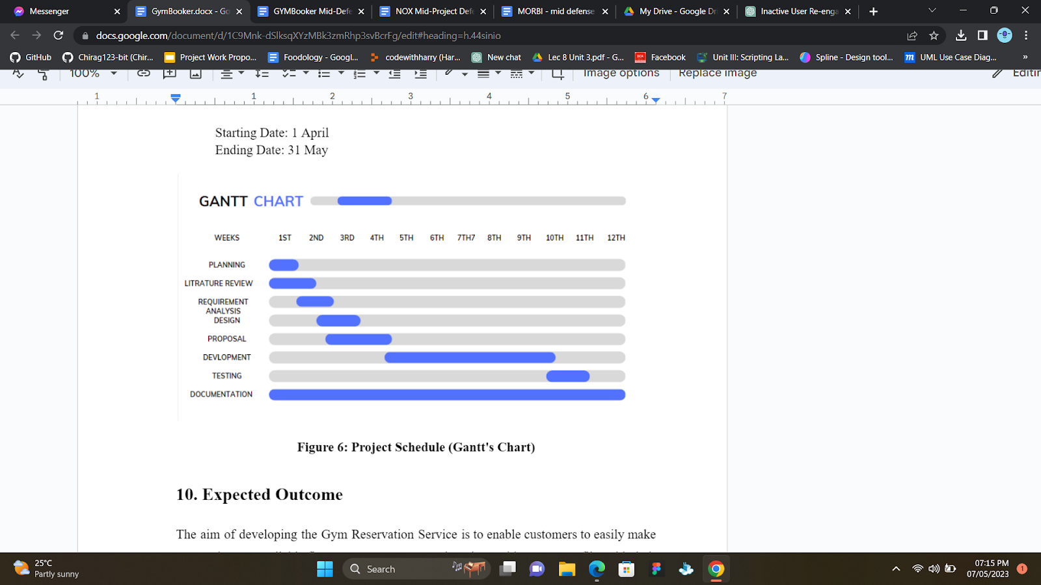The Gantt’s chart below illustrates the time schedule for the completion of the project:

**Figure 3: Gantt's Chart**

**Figure 3: Gantt's Chart of DoseDash System [6]**

### **3.1.3 Data Modeling (ER Diagram)**

An entity-relationship diagram (ERD) is a data modeling technique that graphically represents an information system’s entities and the relationships between these entities. Here in this e-commerce site, the entities are auth_user, dosedashapp_Product, dosedashapp_product_Product,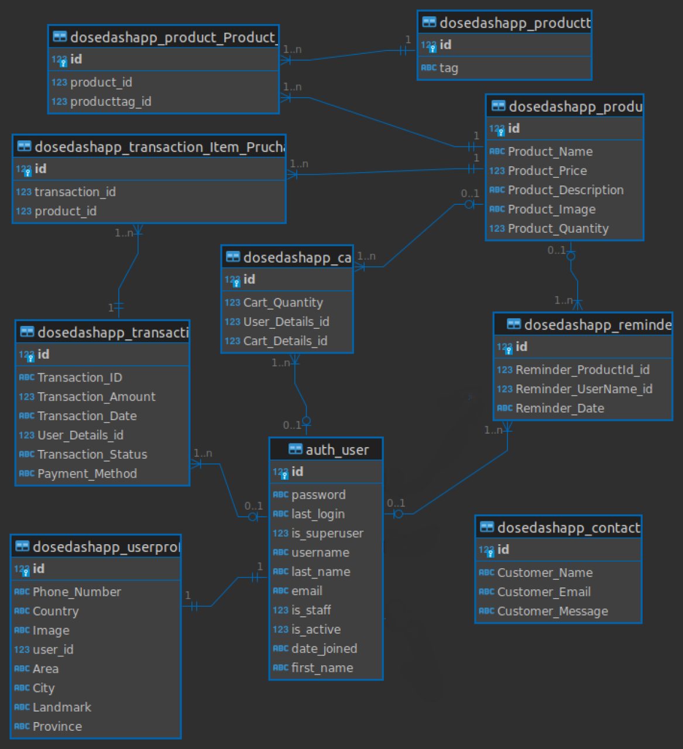dosedashapp_contact,dosedashapp_transaction_item_Purchase, dosedashapp_userProfile, dosedashapp_transaction, dosedashapp_reminder.

**Figure 4: ER Diagram of DoseDash System**

## **3.2 System Design**

System design refers to the process of creating a plan or blueprint for a complex system that meets specific requirements. It involves designing the architecture, components, modules, interfaces, and data for the system, and defining how they interact with each other to achieve the desired functionality.

### **3.2.1 Architectural Design**

Architectural design is about decomposing the system into interacting components. It is expressed as a block diagram defining an overview of this system structure, features of the components, and how these components communicate with each other to share data.

### **3.2.2 Database Schema Design**

Data Schema shows how the data is organized and associated relations among them. In the figure below, the constraints that are applied on the data such as the primary key is represented by a single underline as well as an indication of “PK”.



**Figure 7: Database Schema Design of DoseDash**

### **3.2.3 Interface Design**

The user interface serves as the visual and interactive component of the system, enabling users to interact with and operate the application. In this particular system, an interactive design has been implemented to enhance the user experience and make it easier for the actors (users) to navigate and use the system efficiently.

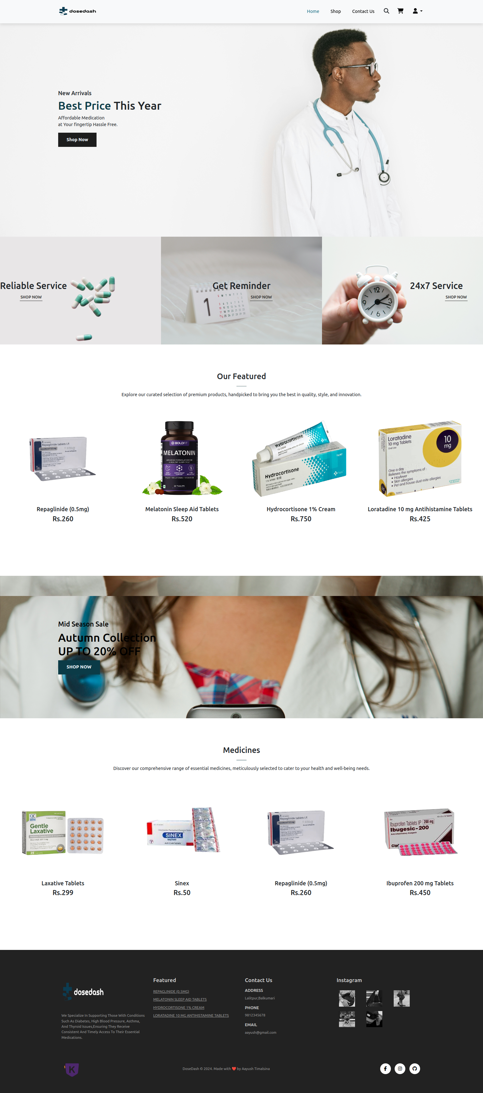

**Figure 8: Homepage of DoseDash**

# **CHAPTER 4****: IMPLEMENTATION AND TESTING**

## **4.1 Implementation**

Implementation refers to the process of turning a design or plan into a working system, product, or service. It involves the actual coding and development of the system based on the specifications and design documents.

### **4.1.1 Tools Used**

The frontend, backend tools and documentation tools used in making this system are:

**i. Front-End:** The initial design of each layout of the website was developed using HTML (Hypertext Markup Language), CSS (Cascading Style Sheet), and JS in Vo Code.

**ii. Back-End:** For the back-end part, Python (Django), SQL Lite were used. Python was used as the programming part of the web application whereas SQL Lite for the database management system.

**iii. Documentation Tools:**

* Microsoft Office: Final reports were prepared using Microsoft Office software.
* Dbeaver: The ER diagram of the system was used from dbeaver.
* Canva: To make a Gantt chart.
* Gitbash and GitHub: Gitbash and GitHub are used for version control and as a code repository.

### **4.1.2 Implementation Details of Modules**

The SFD (System Flow Diagram) shows the flow of the system. As per this system, there are two modules involved: Admin and User.

**User:** In this module, the users can register/login to the system. He/she can view the class details. They can request membership for the desired class. They will also receive reminder mails from after.

**Admin:** In this module, the admin can view/manage the accounts of users. They can update the details of classes and also manage the membership of users. They can also check for the membership status of users and admin can send email to inactive users.



**Figure 9: System Flow Diagram of DoseDash**

## **4.2 Testing**

Testing is a process of executing a program with the intent of finding an error. A good test case is one that has a high probability of finding an undiscovered error. The primary objective for the test case design is to derive a set of tests that has the highest livelihood for uncovering defects in this developed system.

### **4.2.1 Test Cases for Unit Testing**

The unit testing was performed to emphasize the verification effort on the smallest unit of software design i.e., a software component or module. It was performed in parallel with the coding phase. We tested each view/module of the application individually.

Test Case ID: 1

User Interface: Login

Operation: System Login

**Table 1: Unit Test Case - 1 (Login)**

|  |  |  |  |
| --- | --- | --- | --- |
| **Input** | **Action** | **Expected Outcome** | **Status** |
| [xayush.dc@gmail.com](mailto:xayush.dc@gmail.com)  *** | Type correct email and incorrect password | Log in into the system | Fail |
| xayush.dc@gmail.com  ***** | Type email and password (Both Correct.) and login | Log into system with appropriate permissions | Pass |
| yoyo | Type invalid email and blank password and login | Display “Invalid Credentials” | Pass |
| xayush.dc@gmail.com  *** | Type valid email and incorrect password and login | Display “Invalid Credentials” | Pass |

Test Case ID: 2

User Interface: User Homepages

Operation: Logged in customers

**Table 2: Unit Test Case - 2 (User Homepage)**

|  |  |  |  |
| --- | --- | --- | --- |
| **Input** | **Action** | **Expected Outcome** | **Status** |
| Go to dedicated URL | Homepage accessed by user when they login | Access homepage | Pass |

Test case ID: 4  
User Interface: Change Password  
Operation: Change Password

**Table 4: Unit Test Case - 4 (Change Password)**

|  |  |  |  |
| --- | --- | --- | --- |
| **Input** | **Action** | **Expected Outcome** | **Status** |
| Old password: xyz  New password: xyz  Confirm password: xyz | Sets old and new password same | Display “Password can’t be same with old one” | Pass |
| Old password: xyz  New password: abc  Confirm password: abc | Type invalid old password | Display “Current password didn’t match” | Pass |
| Old password: xyz  New password: abc  Confirm password: 123 | Type incorrect confirm password or left empty | Display “Confirm password didn’t match / password cannot be empty” | Pass |

### **4.2.2 Test Cases for System Testing**

The system testing was performed to test the integration of each module in the system. Also, to find the discrepancies between the system and its original objective, current specification, and system documentation.

Test case ID: 1  
User Interface: Customer Query  
Operation: Customer Query

**Table 5: System Test Case - 1 (Customer Query)**

|  |  |  |  |
| --- | --- | --- | --- |
| **Action** | **Input** | **Expected Outcome** | **Status** |
| Customers make query | Customers fill out the query/feedback form | Admin receives customer query through a feedback form | Pass |

# **CHAPTER 5****: CONCLUSION AND FUTURE RECOMMENDATIONS**

## **5.1 Lesson Learnt/Outcome**

Developing this project with the primary goal of learning modern technologies, we have immense exposure in understanding technologies like python not only at the implementation level but also in understanding the background of such technologies. DoseDash is developed where users can login/register into the system and can view and purchase the products. Users can also update their personal details, change their password, and give feedback to the system. Admin can add products, manage product, and receive feedback from the users.

## **5.2 Conclusion**

The website was developed using Django, SQL Lite, JavaScript, HTML and CSS. Any

consumer can browse products, add, or remove a product from the cart and checkout to

complete the purchase. The users can log in, with their information such as their username and password. Admin can add/edit and delete the product once placed on the site.

## **5.3 Future Recommendations**

Here is what can be added in the future on this website to increase its usability, user experience, and portability of the website. There is a lot to be done hence this application can be considered as a starting point for something big to come. It will need more time and resources for all this to be done but it is still very realistic and possible to achieve.

* Numerous reliable features aimed at ensuring customer happiness can be made available.
* Various products can be added so that customers have wide range of variation to choose from.

# **REFERENCES**

[1]. Pharmeasy, “About Us”, 2024. Available at: https://pharmeasy.in/about-us

[2]. Netmeds, “About Us”, 2024. Available at: https://www.netmeds.com/about-us

[3]. 1mg, “Home”, 2024. Available at: https://www.1mg.com/

[4]. Krasamo, “The Agile Development Process for Mobile Apps”, May 31, 2022. Available at: https://www.krasamo.com/agile-development-process/

[5]. Wrike, “What is Agile Methodology in Project Management?, 2023. Available at: https://www.wrike.com/project-management-guide/faq/what-is-agile-methodology-in-project-management/

[6]. Gantt.com, “What is a Gantt Chart?”, 2023. Available at: https://www.gantt.com/

# **APPENDICES**

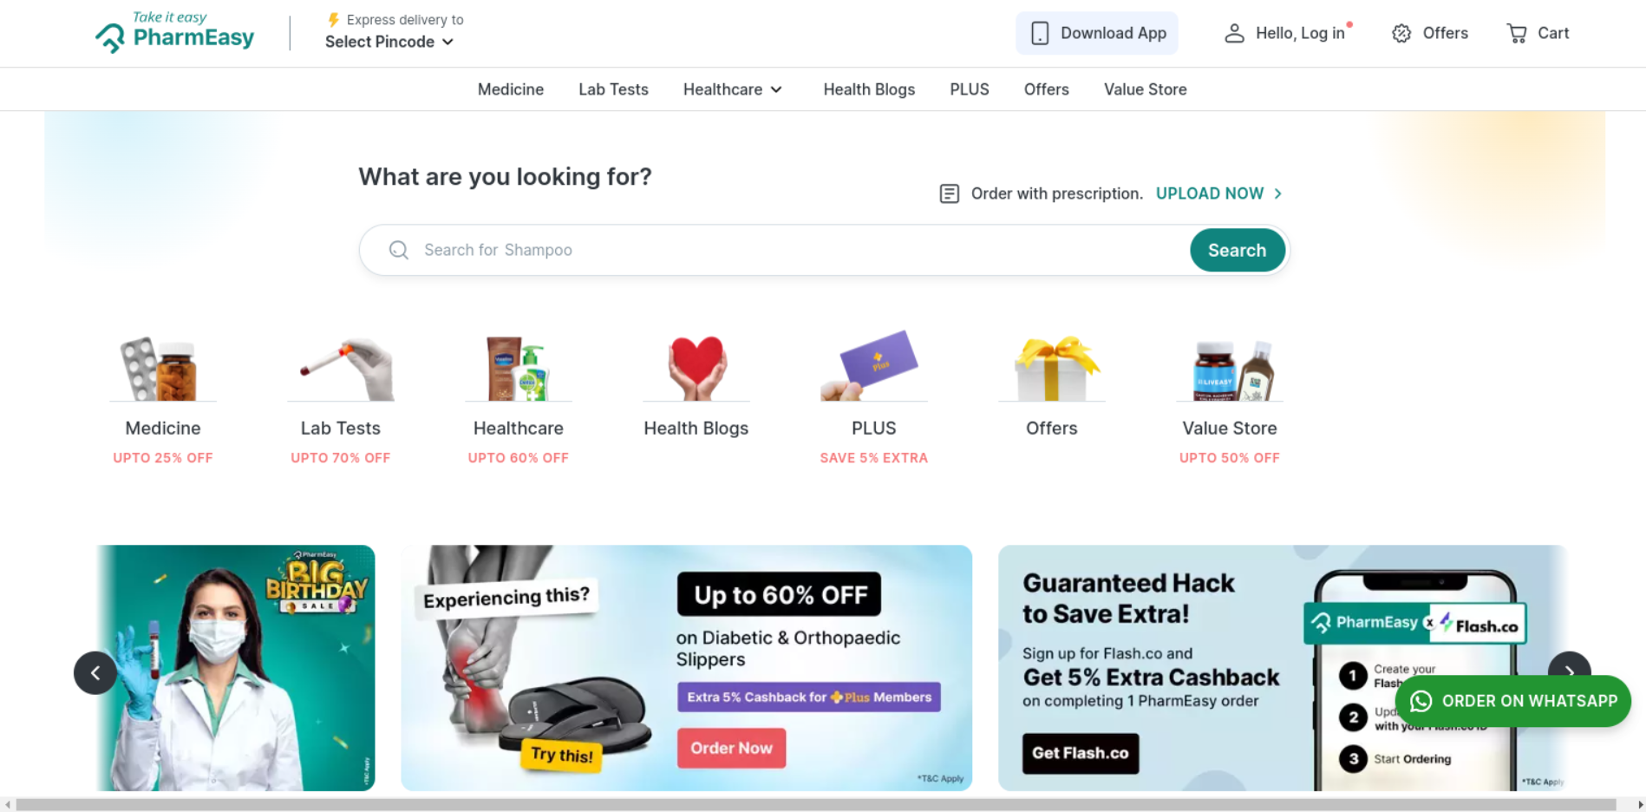

**Figure 10: Pharmeasy Landing Page**

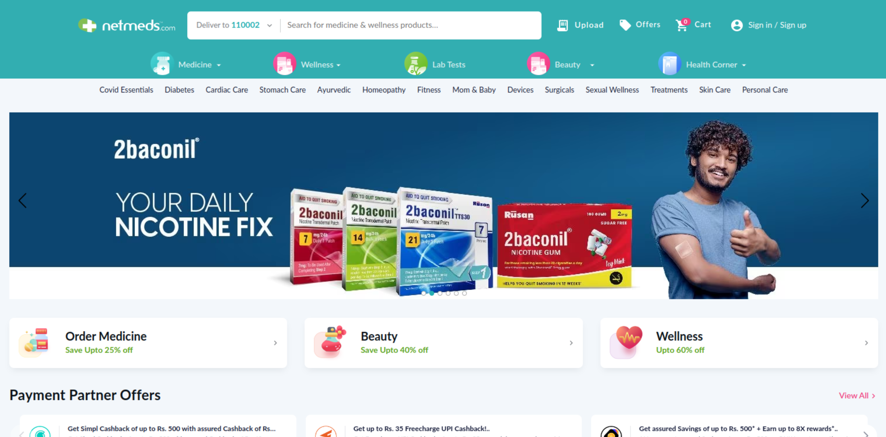

**Figure 11: Netmeds Landing Page**

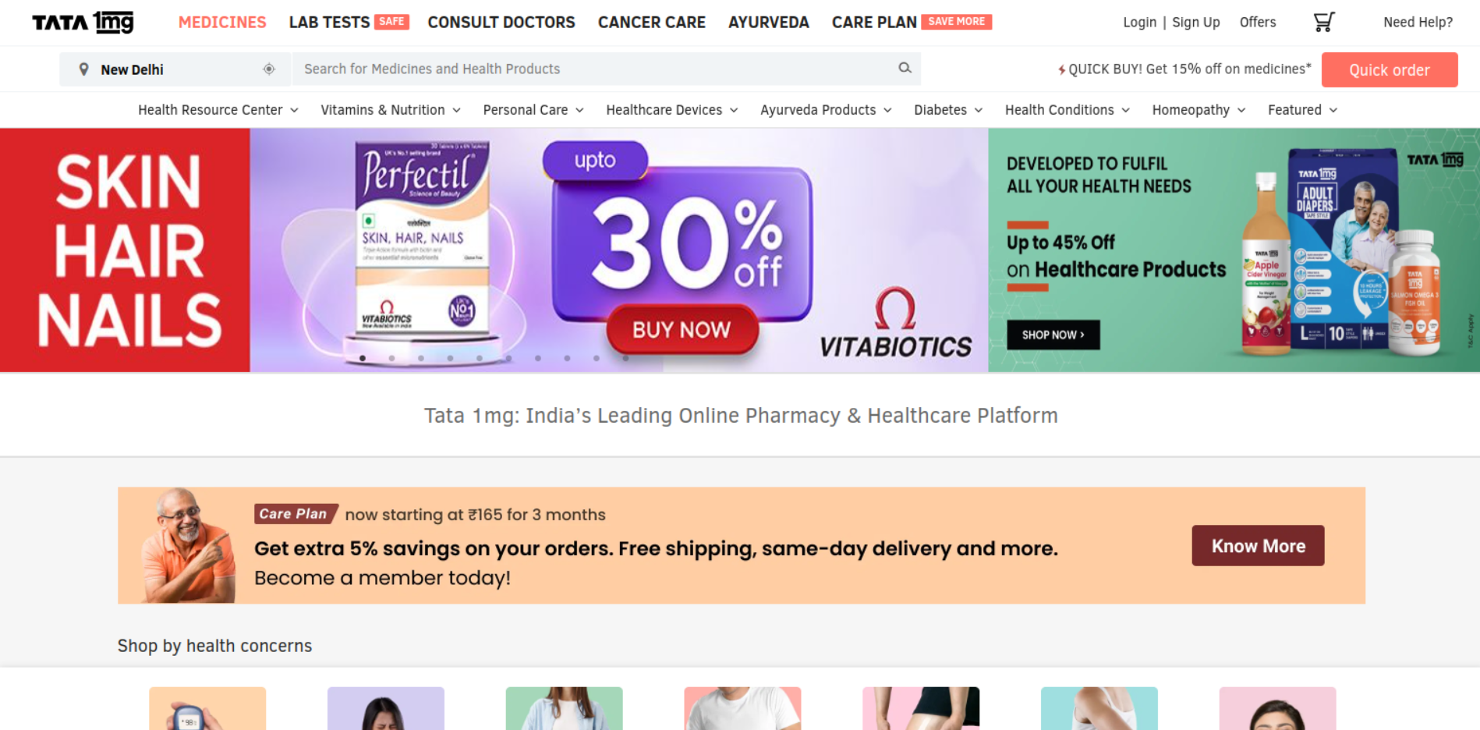**Figure 12: 1mg Landing page**



**Figure 13: DoseDash Landing Page**



**Figure 14: Sign in Page**

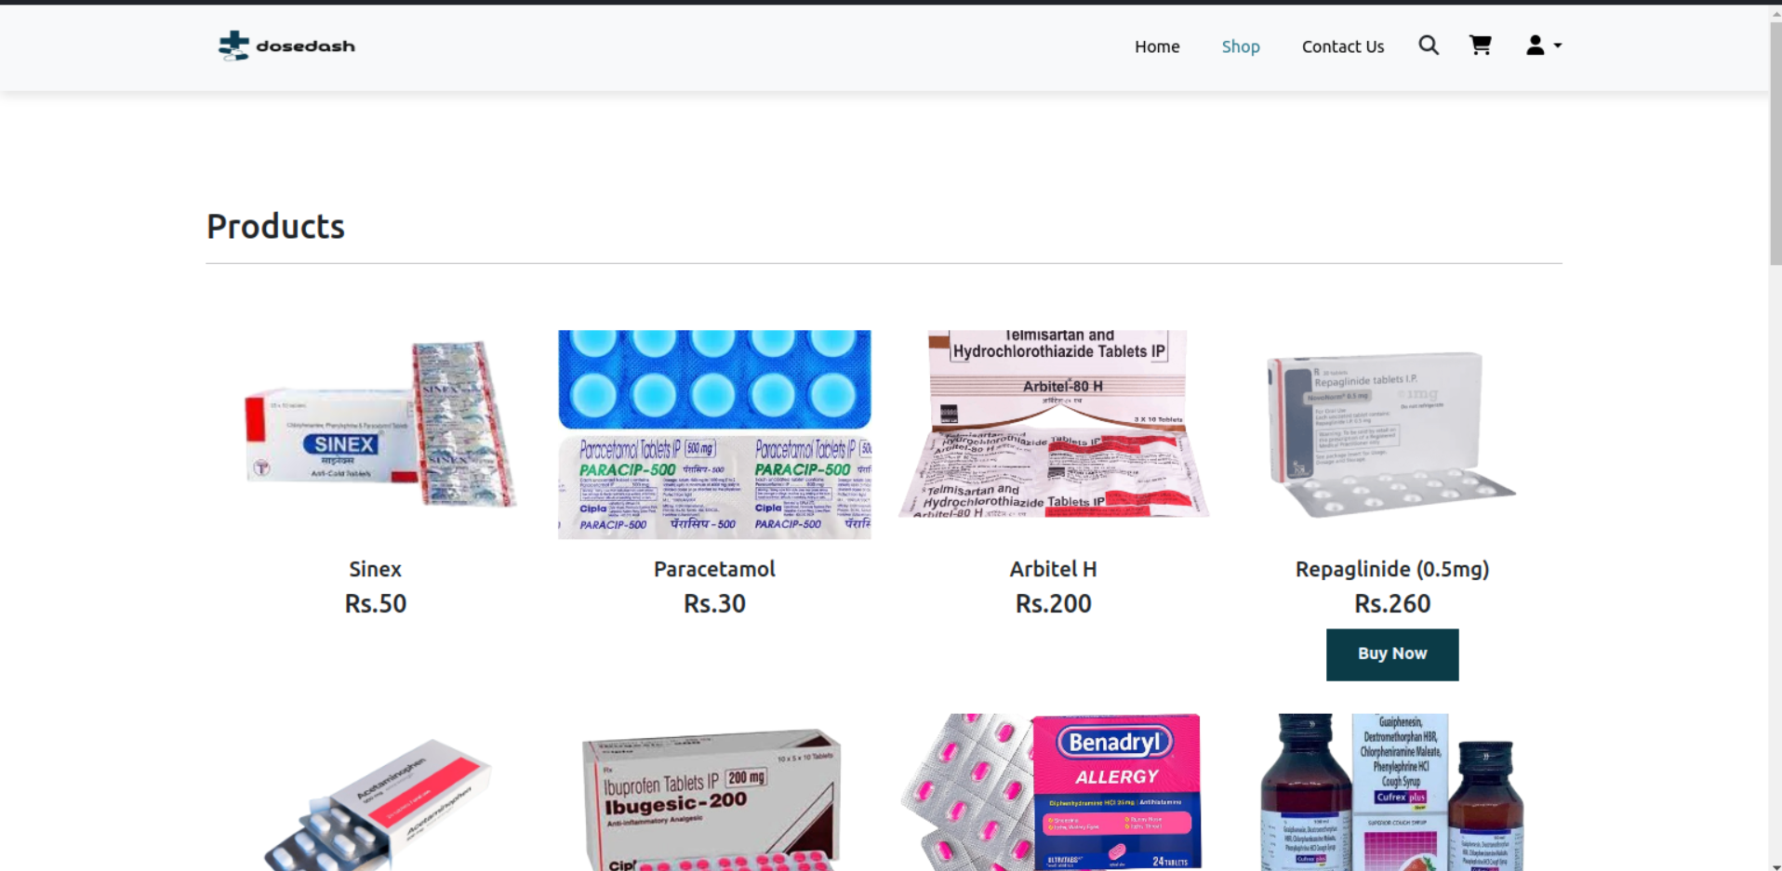

**Figure 15: Shop page of DoseDash**